MINI PROJECT REPORT

ON

DIGITAL SYSTEM AND DESIGN

SMART WHEELCHAIR

Project Mentor – Professor Sushil Kumar Pandey

By - Ashna Sanjay Gaude (221EC112)

Tanushri Chavva (221EC160)



National Institute of Technology Karnataka,

Surathkal, Mangalore – 575025

# *certificate*

This is to certify that the Mini-Project Title entitled “Smart Wheelchair” submitted by Ashna Sanjay Gaude (221EC112) and Tanushri Chavva (221EC160) as the record of the mini-project work carried out by them, is accepted as the Final Mini-Project Report in partial fulfilment of the requirements for the award of degree of Bachelor of Technology.

Dr Sushil Kumar Pandey

Project Mentor

Assistant Professor

Department of Electronics and Communication

NITK Surathkal – 575025

Dr. Nikhil S

Mini-Project Faculty Associate Professor

Department of Electronics and Communication

NITK Surathkal – 575025

ABSTRACT

This is project presents the development of a cutting-edge smart wheelchair system equipped with a suite of advanced technologies to enhance user mobility, safety, and comfort. The integration of a Wi-Fi module, ultrasonic sensors, Arduino Uno microcontroller, and force sensor facilitates intelligent navigation, obstacle detection, and user assistance, catering to the diverse needs of individuals with mobility impairments.

The Wi-Fi module enables seamless connectivity and communication capabilities, allowing the smart wheelchair to interact with external devices, access online resources, and transmit data wirelessly.

Ultrasonic sensors are strategically deployed around the wheelchair to provide accurate and reliable obstacle detection in real-time.

Additionally, a force sensor integrated into the wheelchair seat detects changes in pressure and weight distribution, enabling fall detection and user safety monitoring.

Overall, this project represents a significant advancement in assistive technology, offering individuals with mobility impairments a sophisticated and user-centric solution for enhanced mobility and independence. The integration of Wi-Fi, ultrasonic sensors, Arduino Uno, and force sensor enables intelligent navigation, obstacle avoidance, and user assistance, empowering users to navigate their surroundings with confidence and dignity.

TABLES OF CONTENTS

|  |  |  |
| --- | --- | --- |
| S. no. | Topic | Page number |
| 1. | INTRODUCTION | 5 |
| 2. | MOTIVATION | 6 |
| 3. | LITERATURE REVIEW | 7 |
| 4. | METHODOLOGY AND RESULT | 8 |
| 5. | FUTURE SCOPE | 10 |
| 6 | CONCLUSION | 11 |
| 7 | REFERENCES | 12 |
|  |  |  |
|  |  |  |

# Introduction

Wheelchairs serve as indispensable aids for individuals with restricted mobility, facilitating their movement and enhancing their quality of life in numerous ways. By providing increased mobility, wheelchairs enable users to navigate their surroundings with greater freedom and independence. Beyond mere transportation, they serve as gateways to accessibility, allowing individuals to overcome barriers like stairs and uneven surfaces, thereby granting them access to buildings, public spaces, and transportation systems.

Moreover, the integration of innovative features in wheelchairs holds significant importance in further improving the lives of users. The continual evolution of wheelchair design and technology not only enhances functionality but also addresses specific needs and preferences of individuals. For instance, advancements such as ergonomic seating, customizable controls, and lightweight materials contribute to increased comfort and usability, thereby promoting long-term user satisfaction.

In addition to facilitating daily tasks and social interactions, wheelchairs play a vital role in enabling individuals to pursue employment opportunities and engage in leisure activities. The incorporation of features such as enhanced manoeuvrability and versatile seating options enables users to participate more fully in various aspects of life, fostering greater inclusivity and participation in society.

Furthermore, wheelchairs provide much-needed respite and alleviate fatigue for individuals with mobility disorders, contributing to their overall well-being. By reducing the physical strain associated with movement, innovative wheelchair features promote comfort and mitigate the risk of secondary health issues, thereby supporting long-term health management.

In medical settings, the importance of wheelchairs extends to rehabilitation and mobility training for patients recovering from illnesses or injuries. The integration of advanced features, such as adjustable support systems and rehabilitation-specific accessories, facilitates tailored treatment plans and promotes optimal recovery outcomes.

The ongoing innovation and integration of new features in wheelchairs are essential for continually enhancing the mobility, comfort, and overall quality of life for individuals with restricted mobility. By addressing specific needs and challenges, innovative wheelchair design not only improves accessibility but also promotes greater autonomy, social inclusion, and well-being for users.

# Motivation

Overcoming barriers faced by wheelchair users, such as inaccessible spaces, societal attitudes, and limited healthcare support, is crucial for fostering mobility and inclusion. This necessitates concerted efforts in design innovation, policy reforms, and raising awareness to create a more accessible environment.

Electric wheelchairs, powered by rechargeable batteries and equipped with electric motors for propulsion, offer a revolutionary solution for users seeking effortless mobility. Joystick controlled interfaces or specialized controls, they represent a significant advancement over manual wheelchairs, particularly benefiting individuals with restricted upper body strength or mobility limitations by minimizing physical exertion.

However, while electric wheelchairs offer unparalleled convenience, their complexity and cost cause significant barriers to accessibility for many users. Recognizing this challenge, our focus has been on simplifying the design and reducing costs by leveraging inexpensive components that maintain functionality. This approach aims to provide an economical alternative to traditional electric wheelchairs, expanding access to this essential mobility aid for a broader segment of the population.

In addition to affordability and simplicity, incorporating such as sensors and Wi-Fi module holds immense potential for further enhancing the functionality and user experience of wheelchairs. By integrating sensors for obstacle detection and navigation assistance, wheelchairs can offer heightened safety and autonomy in navigating diverse environments. Furthermore, incorporating Wi-Fi connectivity enables remote control and monitoring capabilities, facilitating seamless integration with smart home systems and enhancing user convenience and independence.

The motivation behind integrating these features lies in our commitment to improving the quality of life for wheelchair users by addressing existing challenges and pushing the boundaries of innovation. By embracing technological advancements and user-centric design principles, we aim to create wheelchairs that not only meet the basic needs of users but also empower them with enhanced functionality, accessibility, and connectivity in their daily lives.

# Literature Review

The increasing demographic of elderly and disabled individuals underscores the critical necessity for advancements in mobility assistance solutions. While both traditional and electric wheelchairs offer support, their inherent limitations often constrain users' autonomy and safety. Moreover, the existing market lacks a comprehensive range of options that can effectively meet the diverse needs of individuals requiring mobility aids.

To tackle these challenges, it is imperative to adopt innovative approaches to wheelchair design and mobility assistance. Manufacturers must prioritize the development of intuitive interfaces, streamlined operation mechanisms, and robust safety features to substantially enhance the overall quality of life for elderly and disabled individuals. By emphasizing user-centric design principles, these advancements aim to empower users with greater independence and confidence in navigating their surroundings.

Furthermore, the integration of cutting-edge technologies, such as sophisticated fall risk assessment methods, holds tremendous potential for further augmenting user autonomy and well-being. These technological innovations offer proactive support mechanisms, mitigating potential risks and enhancing overall safety for users.

Considering the societal implications of an aging population, investing in accessible and adaptable mobility solutions remains paramount. By making strategic investments in research, development, and implementation, we can uphold the dignity and autonomy of individuals across all age groups and mobility spectrums. Ultimately, these concerted efforts contribute to fostering a more inclusive and supportive society, where every individual can thrive irrespective of their age or mobility challenges.

1. METHODOLOGY AND RESULT

We have created a simple system which is cost effective, that will carry out the motion of the wheelchair as well as have additional features such as object detection and fall risk management.

The smart wheelchair we designed mainly includes the following modules:

1. Navigation module:

Our basic navigation module currently consists of ESP8266-NodeMCU, L293D Motor Driver and two Gear motors that are representative of the two wheels of the wheel chair.

We used DC motors to run the wheels of the wheelchair, translating the commands from the ESP8266 into physical movement.

L293D is the motor driver, it serves intermediary between the ESP8266 and the DC motors.

1. Sensors:

We have integrated the wheelchair with an ultrasonic sensor and buzzer for obstacle tracking and a force sensor for fall detection.

The ultrasonic sensor is used to prevent from collision. We used the HC-SR04 ultrasonic sensor which has a frequency of 40kHz. The microcontroller is always processing the values it receives from the ultrasonic sensor and sending values to the DC motors to control the motion of the wheelchair to prevent its users from colliding with obstacles or in crowded situations. The sensor is also interfaced with a buzzer that is set off when the ultrasonic sensor detects a distance less than 20 cm informing the wheelchair user of an obstacle.

The force sensor detects whether the user is seated in the wheelchair. It is basically a resistor and based on the amount of force applied on it the resistance either increases or decreases giving us the respective reading. Once the system is in operation if the sensor does not receive any value, i.e. the person is not applying any force and has fallen off the chair for more than a certain amount of time i.e., 1min, the buzzer will set off alerting people.

1. Wi-fi Module:

ESP8266 is a microcontroller with integrated Wi-Fi and dual mode Bluetooth. It is added to the system to wirelessly send values from and to the Arduino. It helps make the system more seamless and user-friendly. It takes the values of obstacle distance and help display it to the user as well as allow alerts to be sent when force sensor doesn't detect any value for a certain amount of time.

We have used the Access Point mode of the ESP8266 which means that we are using the Wi-Fi of the ESP and not connecting to the internet. On the SSID’s local IP, we have setup a website that helps in the wireless usage of the system. The website facilitates in sending requests to the ESP which in turn processes them and carries out the required actions.

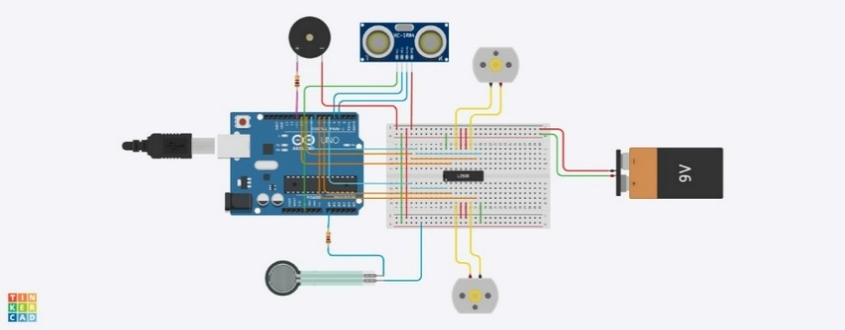

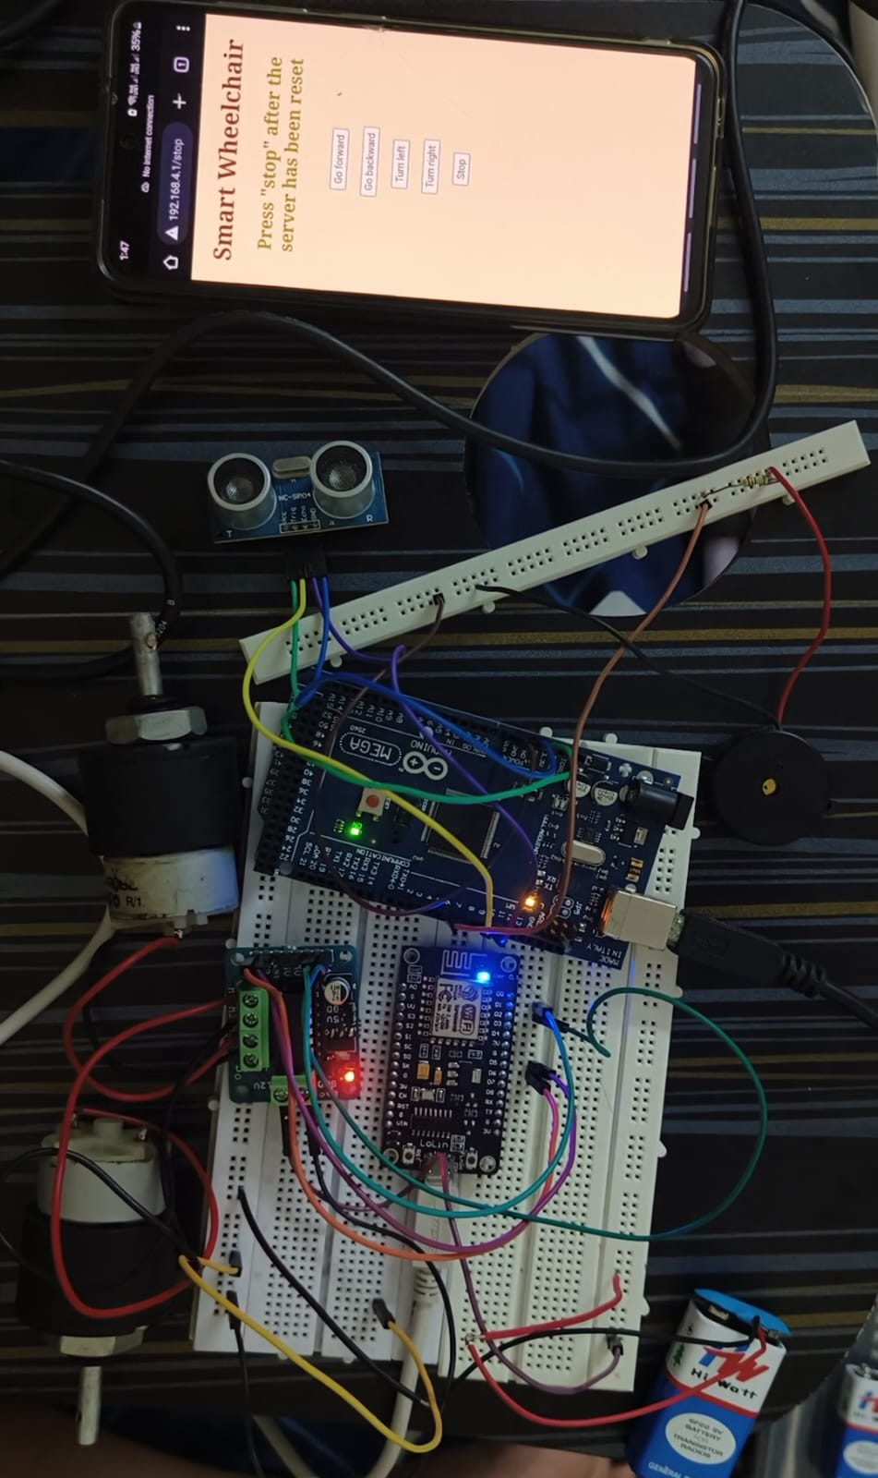 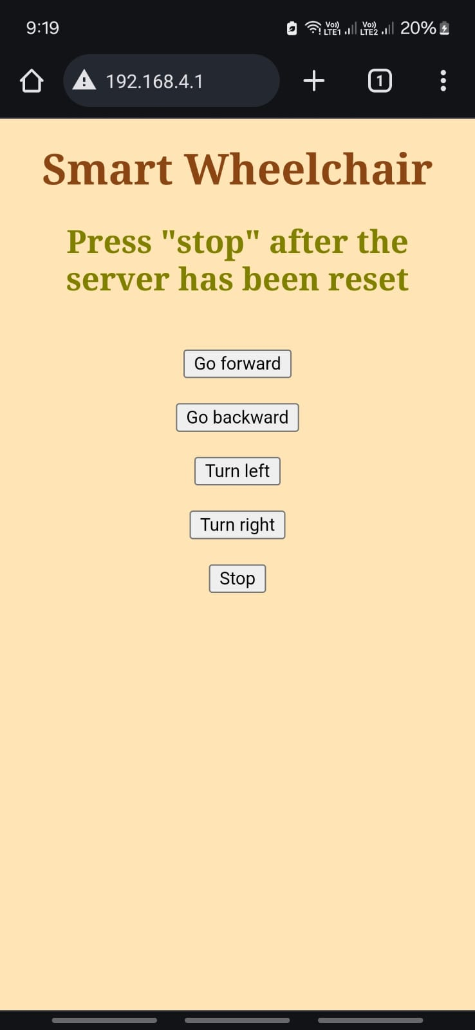

1. FUTURE SCOPE
2. Localization:

Adding localization in wheelchairs would be a pivotal advancement that revolutionizes their functionality, safety and usability. It would enable precise positioning and enhanced navigation. By incorporating sensors and algorithms to determine the wheelchair's location, users gain autonomy, safety, and confidence in manoeuvring through diverse environments. This advancement represents a significant stride towards empowering individuals with mobility impairments to navigate the world with greater independence and ease.

1. Mobile application:

A mobile application tailored for a smart wheelchair would serve as a versatile control interface, offering users unprecedented convenience and flexibility. With intuitive features such as remote control, route planning, and real-time monitoring, users can effortlessly interact with their wheelchair, customize settings, and navigate with confidence. Additionally, the application could provide valuable insights into the wheelchair's status, battery life, and location, empowering users to stay informed and connected wherever they go. Overall, the mobile application will elevate the smart wheelchair experience, making mobility assistance more accessible, efficient, and user-friendly.

1. Voice control:

Incorporating a voice control feature into a smart wheelchair would significantly enhance accessibility and convenience for users. With voice commands, individuals with mobility impairments can operate the wheelchair hands-free, empowering them to navigate their environment more independently. Whether it's directing the wheelchair to move forward, turn, or stop, or activating specific functions such as adjusting speed or accessing navigation assistance, voice control offers a seamless and intuitive way for users to interact with their wheelchair. Additionally, voice control can be integrated with other smart features, such as controlling lights, adjusting seat position, or accessing environmental information, further enhancing the overall user experience and promoting greater autonomy and freedom of movement.

CONCLUSION

In conclusion, the development of our smart wheelchair marks a significant leap forward in assistive technology, offering individuals with mobility impairments an advanced, user-centric solution for improved mobility, safety, and autonomy. By integrating innovative features such as the ESP8266 WiFi module alongside ultrasonic sensors, Arduino Uno microcontroller, and force sensor, we have crafted a versatile and intelligent mobility aid tailored to meet the diverse needs of users.

The incorporation of the ESP8266 WiFi module revolutionizes connectivity and communication capabilities, enabling seamless interaction with external devices and online services. This connectivity empowers users with remote monitoring, firmware updates, and integration with smart home systems, enhancing convenience and accessibility while fostering independence.

Ultrasonic sensors play a pivotal role in ensuring user safety by providing real-time obstacle detection and collision avoidance. By detecting nearby objects and obstacles, the wheelchair navigates complex environments with confidence, mitigating risks and bolstering user confidence in their surroundings.

The Arduino Uno microcontroller serves as the neural hub of the system, orchestrating operations and controlling various components. Through bespoke software algorithms, it interprets sensor data, executes navigation commands, and coordinates user inputs, delivering responsive and adaptive control over the wheelchair's movements.

Additionally, the integration of a force sensor adds an additional layer of safety and assistance by facilitating fall detection and posture monitoring. Continuously monitoring user posture and seat occupancy, the wheelchair promptly detects and responds to potential safety hazards, ensuring timely assistance and intervention.

In sum, our smart wheelchair embodies a collaborative endeavor to harness technology for the benefit of individuals with mobility impairments. By prioritizing user-centric design and incorporating cutting-edge features, we strive to empower users with confidence, dignity, and independence in navigating their environment. As we move forward, our commitment to continual refinement and innovation remains unwavering, dedicated to further enhancing the functionality, accessibility, and usability of our smart wheelchair to enrich the lives of those who rely on it.

##### References

##### Edward T. H. Chu, SWAF: Smart Wheelchair for Fall Risk Assessment, <https://www.sciencedirect.com/science/article/pii/S1383762122001941?ref=pdf_download&fr=RR-2&rr=860950428b6af3d9>

##### Bingqing Zhang, Understanding Interactions for Smart Wheelchair Navigation in Crowd, <https://dl.acm.org/doi/pdf/10.1145/3491102.3502085>

##### Sumit Desai, Dr S. S. Mantha, Dr. V.M. Phalle, Advances in Smart Wheelchair Technology Sumit Desai, Dr. S. S. Mantha, Dr. V.M. Phalle, <https://ieeexplore.ieee.org/stamp/stamp.jsp?tp=&arnumber=7947914&tag=1>